Create and Inspect a Docker Volume for Backup
Volume:
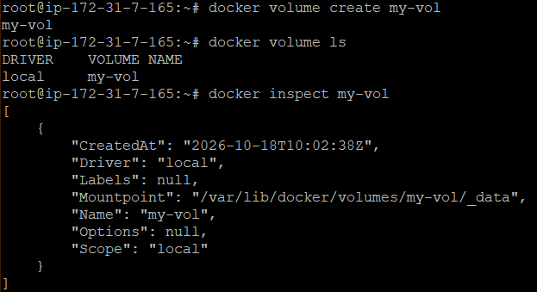
Image created:
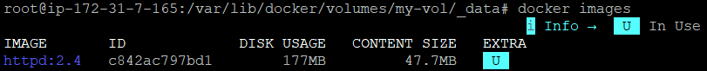
Apache container running and index.html is present:
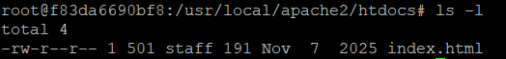
Sample file created in the container:
Container stopped:
Container removed:
Recreated a container using the same volume:
File exists in that container even when the previous container was deleted:

